THEME: THE HUMAN HEALTH
TOPIC: OUR FOOD
What is food?
Food is something good to eat or drink.
What is feeding?
Feeding is the taking in of food.
Sources of food in the environment
-plants
-animals
Main source of food in the environment
-plants
How do people get food?
-By buying food
-By growing crops
-By hunting animals
-By gathering from forests and bushes.
-By fishing.
Places where we get food
-waterbodies
-forests
-gardens
-shops
-markets
Why people eat food
-To have good health
-To get energy
-To grow

Importance of food in the human body
For body health
For body growth
For production of energy
For repairing worn out body tissues.
NB:
Some food values can be described as 3Gs in accordance to way they perform in the body.
- Glow foods [ mineral salts and vitamins]
- It is a class of food that gives health and protection to the body.
- Go foods [ carbohydrates]
- It is a class of food that gives energy to the body
- Grow foods [ proteins]
- It is a class of food that gives or makes the body to grow.
A balanced diet is a meal that contains all food values in their correct amount needed by the body.
Foods values that make up a balanced diet

- Carbohydrates
- proteins
- vitamins
- mineral salts
- fats and oils
- roughages
- water

CARBOHYDRATES
- These are food values that provide energy to the body
Food sources of carbohydrates

- Milk
- Bread
- Jam
- Sweet potatoes
- Cassava
- Maize
- Irish potatoes
- Yams

Lack of food or carbohydrates in the diet causes marasmus or starvation.
poor feeding can also cause marasmus in children.
Signs of marasmus
- Bright eyes
- Elderly face
- thinness
- pot belly stomach
Symptoms
-The child is underweight
Prevention of marasmus
-Feeding on food rich in carbohydrates.
PROTEINS
- These are food values that build the body.
Uses of proteins in the body
- They are responsible for body growth
- They replace worn-out body cells or parts
- They repair worn out body tissues.
- They help to make anti-bodies and enzymes
Food sources of proteins

- meat
- Groundnuts
- Cheese
- Eggs
- Fish
- Beans
- Milk
- Soya beans

Plant proteins animal proteins
-fish
-beans -milk
-soya -meat
-groundnuts -cheese
-peas

Lack of proteins in a diet causes kwashiorkor
Signs of Kwashiorkor
- A swollen face
- Brownish hair
- A swollen stomach full of air
- Swollen hands and legs
Prevention of kwashiorkor
-feeding on food rich in proteins.
VITAMINS
- These are food values that give health and protection to the body.
Vitamins | Food Sources | Deficiency diseases and symptoms
A | Liver, egg yolk, carrots, butter cord liver oil, green leafy vegetables | -night blindness(disease)  - Poor eye sight.  -reduced night vision(symptom)
B₁ | Palm wine, beans, lean meat, egg yolk, milk, kidney bread, unpolished cereals, groundnuts | - Beriberi(disease)  - Lack of appetite(symptom)  - Paralysis  (symptom)
B₃ | As for B1 plus yeast extracts | - Pellagra
C | Fresh fruits and vegetables, prepared concentrated frits | - Scurvy(disease)  - Bleeding of gum(symptom)  - Anaemia
D  It is formed in the skin with the help of sunlight | Liver, milk, egg yolk, fish, margarine | - Rickets(disease)  - Poor teeth(sign)  - Weak bones(symptom)  - Bow-shaped legs  (sign)

Note
A deficiency disease is a disease caused due to lack of certain food values in the body.
Categories of deficiency diseases
a) Vitamin deficiency diseases
These are diseases caused due to lack of vitamins in the body.
Examples of vitamin deficiency diseases
Pellagra, rickets, beriberi, night blindness and scurvy
MINERAL SALTS
- These are food values that give health and protection to the body
Examples of mineral salts
Mineral salt | Sources | Function
Calcium | Milk, fish, whole grain cereal, cheese, beans bread, hard water, finger millet | - Makes bones and teeth strong.  - Prevents rickets
phosphorous | Dairy foods, meat, fish, milk, eggs, cheese, cereals and green leafy vegetables | - Makes bones and teeth strong.  - Helps in absorption of carbohydrates.
Iron | Meat, liver, kidney, egg yolk, green leafy vegetables, cocoa | - Helps in formation of haemoglobin  - Lack of iron causes anaemia
Iodine | Sea water, sea food, sea weeds like algae and iodized salts | - It helps in the  - proper working of the thyroid glands  - Lack of iodine causes goitre

Mineral deficiency diseases-are diseases that caused due to lack of certain mineral salts in the body.
Examples of mineral deficiency diseases
-anaemia
-goitre
-rickets
FATS AND OILS
- These provide the body with energy and heat in the body.
- In mammals, fats are stored under the skin
Food sources of fats and oils

- milk
- butter
- egg yolk
- ghee
- groundnut
- palm oil
- simsim
- cheese

Functions of fats and oils
- Fats and oils provide warmth and energy
- They protect the heart and kidney
- They assist in making body cells
Note
- Too much fats and oils in a diet can lead to obesity.
Effects of inadequate fats and oils in the body

- lack of energy
- thinness
- feeling cold
- vitamin A and D deficiency

ROUGHAGES (dietary fibres)
These are undigestible fibres from the cell walls of plants

- Green leafy vegetables
- Sweet potatoes
- Bread and flours
- Cassava
- Fresh fruits
- Peas
- Rice
- Nuts and seeds
- Dried fruits

Functions of roughages
- It allows easy movement of food through the intestines
- It adds bulk to food
- It aids digestion
- It helps to prevent constipation
- Reduces the risk of bowel cancer
- Encourages chewing of food
Lack of foods containing roughages in the diet leads to constipation.
Constipation is the inability to pass out stools easily.
WATER
- sources of water
Uses of water in the body
- Water helps in easy digestion and absorption of food
- It helps in reducing body temperature by sweating
-It forms the basis of blood plasma
How food gets contaminated

- By serving food using dirty hands
- By serving food using dirty containers
- By leaving it uncovered
- Preparing food from dirty places
- Keeping food in dirty places or containers
Effects of food contamination
-It leads to diarrhoeal diseases like typhoid.
-It results into stomach disorders.

Prevention of food contamination

- By covering food properly
- Serving food in clean containers
- Serving food from clean places
- Preparing food with clean hands

Food preparation (cooking) methods
-Boiling food -Frying food
-Steaming
-Roasting food
-mingling
Food preservation is the keeping of food for a long time without going bad
-Smoking -Refrigerating
-Sun drying
-Salting
-tinning/canning
Advantages of preserving food
-It keeps away germs from food
-It promotes food security.
Food hygiene: Is the keeping of food clean or free from germs.
Ways of promoting food hygiene
-preparing food in a clean place.
-washing hands before serving food.
-serving food in clean containers.
Importance of promoting food hygiene
-It controls food contamination.
-It preserves food to control wastage.
Dangers of poor handling of food
-Germs are easily spread.
-It makes food go bad.
-It causes food poisoning.
Food poisoning is an illness caused by food contamination.
Food security is the ability of a family to have enough food to eat and for future use.
Ways of achieving/getting food security.
-growing enough food.
-proper food security.
-preserving of food.
-practising good farming methods.
-growing drought resistant food crops.
Importance of food security
-It prevents deficiency diseases
-Family gets enough food throughout the year.
Good eating habits
-Washing hands before eating food.
-Chewing food properly.
-Do not eat while talking.
Dangers of bad eating habits
-indigestion
-diarrhoeal diseases
-choking
THEME: HUMAN BODY
TOPIC: THE HUMAN BODY ORGANS
An organ is a group of tissues that perform the same function in the body.
A cell is the smallest unit of the body.
A tissue is a group of body cells.
Major organs of the human body include;

Eyes
Brain
Ears
Stomach
Urinary Bladder
Heart
Lungs
Liver
Kidney

THE EYES
-people have a pair of eyes.
-The eye is protected by eye socket(orbit).
Uses of eyes
-Eyes are used for seeing/sight.
-Eyes help in estimating distance.

Diagram of the front view of the eye
Eyebrows
Eyelashes
Upper eyelid

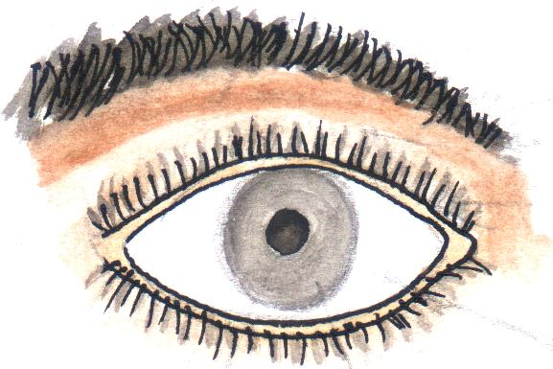
Lower eyelid
Pupil

Sclera
iris

Functions of the parts
a) Eye brows-prevent sweat from flowing into the eye.
b) Eye lashes -trap dust.
c)Eye lids- protect eyes from foreign bodies.
d)The iris- helps to control the amount of light that enters the eye.
e) Pupil- lets in light into the eye.

Diseases that affect the eye

- Trachoma
- conjunctivitis
- river blindness
- sty
- cataracts
- night blindness

Eye disorders
-double vision
-squints
-short sightedness
-long sightedness
-old age sight

Ways in which eye diseases can be spread
-poor feeding
-sharing face towels with an infected person.
Ways of caring for the eyes
- Washing eyes with clean water and soap regularly
- do not touch the eyes with dirty hands
- Do not share materials or shake hands with persons with eye diseases or infection
- Visiting the oculist in case of any eye problems

THE EAR
- The ear is the sense organ for hearing
- The ear helps in body balancing
Structure of the outer ear

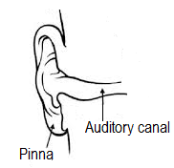

Pinna
- It helps to collect, trap and direct sound to the ear drum.
Qn. Why is a pinna able to trap and direct sound waves to the eardrum?
-It is large and broad.
Auditory canal
- It is the passage for sound waves to the ear drum
- The auditory canal contains special sebaceous glands which secret wax
- Ear wax and hair help to trap dust and germs that enter into the ear.
Diseases of the ear
-ear boils
-otomycosis
-otitis

Disorder of the ear
-Deafness -Ringing of the ears (tinnitus)

Care for the ears
-Do not use sharp objects to clean ears
-Wash ears daily with soap and clean water
-Do not stay in a very noisy place
-Always visit ear nose throat doctor (ENT) for check up
THE NOSE
-It is found in front of the face.
-It has two nostrils (take in and out of air of the body.)
-The nose is used for smelling.
-The nose has hair called cilia.
-Cilia traps dust that comes with air/filters air.
-The nose has mucus which moistens the air.
Disorders of the nose
-blocking of the nose
-mucus
Diagram of a nose
THE BRAIN
-The brain is found in the head
- The brain is protected by the skull or cranium
Uses of brain
-for memory
-for thinking
-for controlling body movement
-for storing information
-for interpreting information
Diagram showing the brain
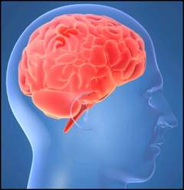

Disease of the brain

- Epilepsy
- Poliomyelitis
- Stroke
- Meningitis
- Almery disease
- Cerebral malaria

-brain cancer

Disorders of the brain
-Autism
-brain tumours
-loss of memory
-inflammation of the brain

Care for the brain
-having enough rest.
-feeding a balanced diet
-having regular body exercises
-treating malaria early
-avoid tobacco smoking
THE LIVER
-The liver is the largest internal body organ.
- The liver is a reddish – brown organ which lies just below the diaphragm and partly covering the stomach.
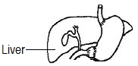

Functions of the liver
-It regulates blood sugar
-It produces bile
-It helps to produce heat
-It helps to store vitamin A and D
-It regulates the amount of proteins
-It removes harmful substances like alcohol
Diseases of the liver
- Cirrhosis of the liver:
- Hepatitis B
- Liver abscess (it is a disorder)
- Liver cancer
Care for the liver
-feeding on a balanced diet
-boiling water for drinking
-performing regular body physical exercises.
-immunising against hepatitis
-avoid drinking a lot of alcohol.
THE STOMACH
- The stomach is a large muscular sac.
-It is part of the digestive system.
-It is located in the abdominal cavity.
-The stomach walls help to produce gastric juice and hydrochloric acid.
a) Hydrochloric acid-kills germs taken in with food.
b) Gastric Juice-It contains enzymes like: pepsin and rennin
Structure of the stomach

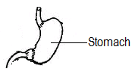

Diseases of the stomach
-gastric ulcers
-peptic ulcers
-dysentery
-cholera
-stomach cancer
Disorders of the stomach
- Peptic ulcers
- Constipation
- Indigestion
- Gastritis
Care for the stomach
-avoid taking a lot of alcohol.
-drinking enough water.
-performing physical body exercises regularly.
-eating the right amount of food.

THE HEART
-It is found in the chest cavity.
-It is protected by the rib cage.
- It helps to pump blood to all body parts
- The heart has four chambers.
Diagram of the heart
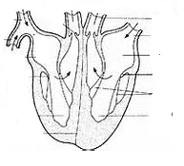

Diseases of the heart
-Coronary heart disease(thrombosis)
- High blood pressure
- Heart stroke
- Heart murmur
Heart disorders
-Heart failure
-Heart attack
Ways of maintaining proper working of the heart
- Feeding on a balanced diet
- Always have regular meals
- Eat meals containing low animal fat
- Doing regular body exercises

The kidney and urinary bladder
- The kidneys are two bean shaped organs situated at either side of the lower abdomen.
- The kidneys are protected by the pelvis.
Urinary bladder
-Stores urine for some time
Diagram of the kidney and urinary bladder

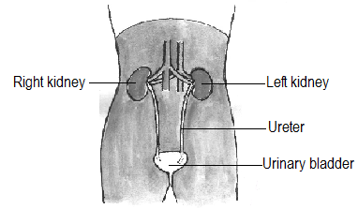

Functions of the kidney
- It helps to filter blood
- It controls the amount of water and salt levels in the blood.
Note:
- The ureter helps to carry urine from the kidneys to the urinary bladder
Disease of the kidneys
- Nephritis
- Kidney cancer
- Bilharziasis
Kidney disorders
-kidney failure
-kidney stones

Care for the kidneys
- Feeding on a balanced diet
- Boiling water for drinking
- Do not hold back urine
- Performing regular body physical exercises
- Avoid swimming in dirty water
- Do not eat or take too much salt
THE TONGUE
-It is found in the mouth
Uses of the tongue
-for tasting
-for rolling food into bolus
-helps in swallowing food.
-Diagram of the tongue
Care for the tongue
-Don’t eat hot food.
-Don’t put sharp objects in the mouth.
THE LUNGS
-People have two lungs. Like: left lung and right lung.
-lungs are used for breathing.
-lungs are also used for excretion.
-lungs are protected by the ribcage.
-Gaseous exchange takes place in air sacs
Lungs are protected by the rib cage
Qn. What is breathing?
Breathing is the taking in and out of air.

Diagram showing lungs

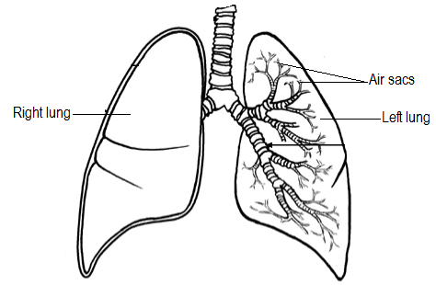

Diseases of the lungs

- Pneumonia
-lung cancer
- Bronchitis
- Tuberculosis
- Diphtheria
- Whooping cough
- Asthma

Ways of maintaining proper working of lungs
- Do not smoke tobacco
- Avoid being in places with a lot of smoke
- Avoid being in dusty places
- Feeding on a balanced diet
- Carry out regular physical exercise
THE SKIN
-It is the largest external body organ.
-It has two layers. i.e.: epidermis and dermis
Uses of the skin
-It regulates body temperature.
-It removes sweat from the body.
-The skin makes vitamin D by the help of morning sunshine.
-It prevents the entry of germs n the body.
-It protects underneath layers from damage.
Skin diseases
-leprosy -measles
-ringworm infection -chicken pox
-athlete’s foot -eczema
-scabies
Skin disorders
-pimples -albinism
Care for the skin
-bathing regularly
-don’t share clothing.
THEME: HUMAN BODY
TOPIC: THE TEETH
- The teeth are hard bone like- structures found in the mouth
Uses of the teeth
-Teeth help in articulation of words.
-They protect the tongue from damage.
-Teeth break food into smaller pieces.
-They maintain the shape of the mouth.
Sets of teeth
- Milk teeth
- Permanent teeth
Milk teeth
- It is a set of teeth which appears first in babies.
- They start falling out one by one and later replaced by the permanent set of teeth
- The milk teeth consist of 20 teeth.
- A child of 2years has 20 teeth.
- A child of 12years has 28teeth.
- The four (4) missing molars are called wisdom teeth.
- The wisdom teeth start to erupt/develop between 18years and 24years.
- It is made up of incisors, canines and premolars.
Qn. Why do milk teeth fall off from the mouth at the age of 6years?
-It is because their roots are dissolved in the gum.

Arrangement of teeth in the milk teeth
Jaw | incisors | canines | premolars | Total
Lower jaw  Upper jaw  Total | 4  4  8 | 2  2  4 | 4  4  8 | 10  10  20

The permanent set of teeth
- This is the second and final set of the teeth in man
- The permanent set of teeth consists of 32 teeth
- It has the following types of teeth
- incisors
- canines
- premolars
- molars
Regions of a tooth
CROWN
- This is the part above the gum mainly the enamel.
NECK
- This is the region on the same level with the gum where the crown joins the root

THE ROOT
This is the part which is sunk or fixed in the socket of the jaw.
TYPES OF TEETH
They include;

- Incisors
- Canines
- Premolars
- Molars

- Incisors.
- incisors are chisel shaped teeth. [adaptation]
- They are flat on top
- Incisors are used for cutting food.
- They are four in each jaw of man.
- Incisors are well developed in;
- rats
- rabbits
- squirrels
Structure of an incisor tooth
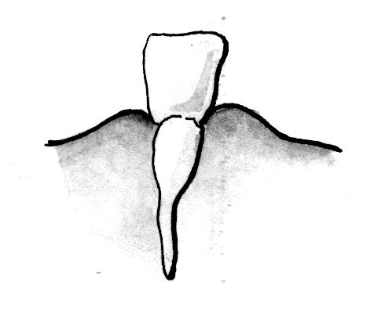

- Canines
- These are sharp cone - shaped teeth
- They are sharp and pointed. [adaptation]
- They are two in each jaw on either side of the incisors
- Canines are used for tearing food.
- They are most developed in carnivorous animals like:

- Dogs
- Cat
- Leopards
- Lions
- Tigers

Structure of a canine tooth

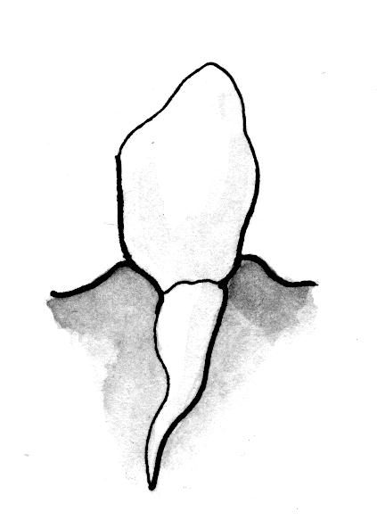

3. Premolars
- These are blunt rigged teeth in front of the molars.
- They have blunt cusps (adaptation)
- They have two roots
- Premolars are used for chewing, crushing and grinding food
- They are four of them placed in pairs after each canine tooth in each jaw
Structure of a premolar tooth
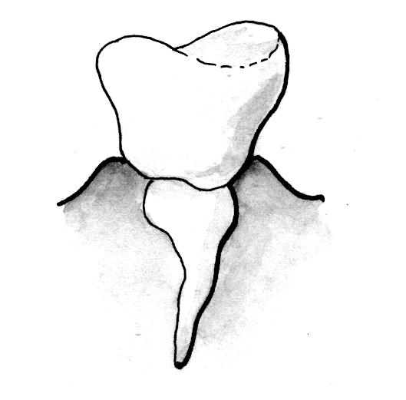

- Molars

- These are blunt cusps and ridged teeth.
- The molars in lower jaw have two roots.
- The molars in upper jaw have three roots.
- They are six in each jaw
Diagram showing structure of molar teeth
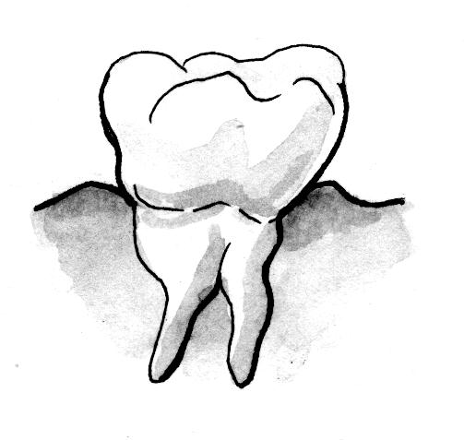

Parts of a canine tooth

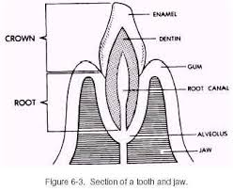

- Molar tooth

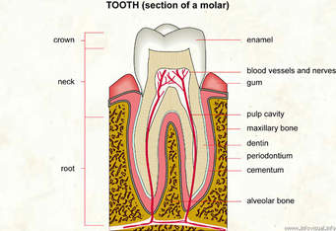

Enamel
  - This is the hardest part of the tooth
  - The enamel prevents wear and tear of the teeth
  - The enamel is made from calcium and phosphorus

Dentine
- It forms the biggest part of the teeth
- It contains living cells and channels through which the dentine receives
Pulp cavity
- It contains blood vessels.
- It has nerves.
- The sensory nerves are sensitive to heat, cold and pain
- The blood vessels bring digested food to the teeth.
Cement
- It fixes the tooth in its socket.
- Gum(gingiva)
- It gives extra support to the tooth into the jaw bone in the jaw bone.
Jaw bone
- It holds the tooth in position
Dentition
This is the arrangement of teeth in the mouth.
TYPES OF DENTITION
a) heterodental dentition-has different types of teeth.
B) homodont dentition- has the same types of teeth.
Dental formula is the formula showing the number and kinds of teeth in the mouth.
Dental formula of an adult person

jaw | Incisors | Canines | premolars | Molars | Total
Lower jaw  Upper jaw | 4  4 | 2  2 | 4  4 | 6  6 | 16  16
Total | 8 | 4 | 8 | 12 | 32

Teeth diseases
- Dental caries/tooth decay
- Periodontitis
- gingivitis
Disorders of the teeth
- Improper growth of teeth
- Broken teeth
- Teeth cracks
- Dental cavities

Care for the teeth
- Brush teeth using fluoride tooth paste
- Avoid eating too much sweets.
- Brush teeth regularly
- Do not drink very hot or very cold drinks.
- Rinse your mouth with clean water every after a meal
- Do not open bottles using the teeth.
Things used to clean the teeth
-toothbrush -toothpaste
-clean water -dental floss
-brushing twigs -charcoal
Dental flossing is the removal of food remains from the teeth using a dental floss.
A dental flossing is a piece of thread used to remove food remains from the teeth.
Qn. State one danger of s

THEME: HUMAN HEALTH
TOPIC: SANITATION
- sanitation is the general cleanliness of a place where we stay or live.
Activities involved in sanitation
- proper disposal of faeces and urine
- proper disposal of house hold refuse like peelings
- Slashing around our homes
- Draining all stagnant water
- Sweeping all rubbish in our compound
- Washing and drying plates.
Importance of sanitation.
-reduces the spread of germs and vectors in the environment.
-reduces bad smell in the environment
-prevents contamination of food and water sources.
- promotes good health.
Germs and diseases
Germs are tiny living organisms which cause diseases.
Germs are commonly found in rubbish pits, pit latrines, air, soil, water, dirty food. Rotting fruits etc
Ways of protecting ourselves against germs
- Proper disposal of faeces and urine.
- Proper disposal of rubbish.
- Water for drinking.

GERMS AND DISEASES
- Germs are tiny living organisms that cause diseases
- Germs are found in;
- water
- soil
- decaying matter
- bodies of animals (man)
- air
- on plants
- blood
- faeces
- urine
Ways how germs are spread
- Through air
- Though insect bites
- Through body contact with an infected person
- Through cuts and wounds on the body
- Through animal bites

Note:
- A disease an illness or disorder caused by an infection or unnatural growth.
- The types of germs include;
- Bacteria
- Fungi
- Protozoa
- virus
- The 4 F’s
- faeces
- flies
- food
- finger
- Germs cause rotting by feeding on the dead organism.

